Question 1: (2012 – 2013, 2014 -2015, 2017 - 2018)
Consider the multicore processor with 6 heterogeneous cores labelled C1, C2, C3, C4, C5, and C6.
Assume cores C1 and C6 have the same speed. C2 runs twice as fast as C1 and core C3 runs 3
times faster than C1, and C4 and C5 are four times faster than C1. Assume all six cores start
executing the application CUBE-X at the time and no cache misses are encountered in all core
operations. Suppose the CUBE-X application computes the cube of each element in an array of
1024 elements. Assume 1 unit of time for C1 (or C4) to compute the cube of an element.

Given the following division of labour in six cores:

C1 64 elements
C2 128 elements
C3 64 elements
C4 512 elements
C5 128 elements
C6 128 elements

- Compute the total execution time (in time units) for the six-core processor to compute the cube of1024 elements in parallel. Remember elements may finish before other but the time to completeshould be defined by the last core to complete.

- Compute the average processor utilisation rate.

ANSWER:

As given c1 take 1unit of time to compute the cube of an element
Total time taken by to compute cube of 64 element =64
Speed of c1=c6
Total time taken by c6 to compute cube of 128 element =128

C2 run twice of c1
Mean c2 take 1/2 unit of time to compute cubic of an element
Total time required for c2=1/2*128=64
C3 runs thrice of c1
C3 required time=(1/3)*64=64/3
C4 and c5 run 4times of c1
So c4 and c5 take 1/4 unit of time to compute cubic of an element
Total time required by c4=(1/4)*512=128
Total time required by c5=(1/4)*128=32
So total execution time=128

*********************************************************************************************************************
Question 2: (2012 – 2013, 2013 – 2014, 2016 - 2017)

Consider the multicore processor with 4 heterogeneous cores labelled C1, C2, C3, and C4.
Assume cores C1 and C4 have the same speed. C2 runs twice as fast as C1 and core C3 runs 3
times faster than C1. Assume all four cores start executing the application SQUARE-X at the time
and no cache misses are encountered in all core operations. Suppose the SQUARE-X application
computes the square of each element in an array of 256 elements. Assume 1 unit of time for C1 (or
C4) to compute the square of an element.

Given the following division of labour in four cores:
C1 32 elements
C2 128 elements
C3 64 elements
C4 32 elements

Compute the total execution time (in time units) for the four-core processor to compute the square
of 256 elements in parallel. Remember elements may finish before other but the time to complete
should be defined by the last core to complete.
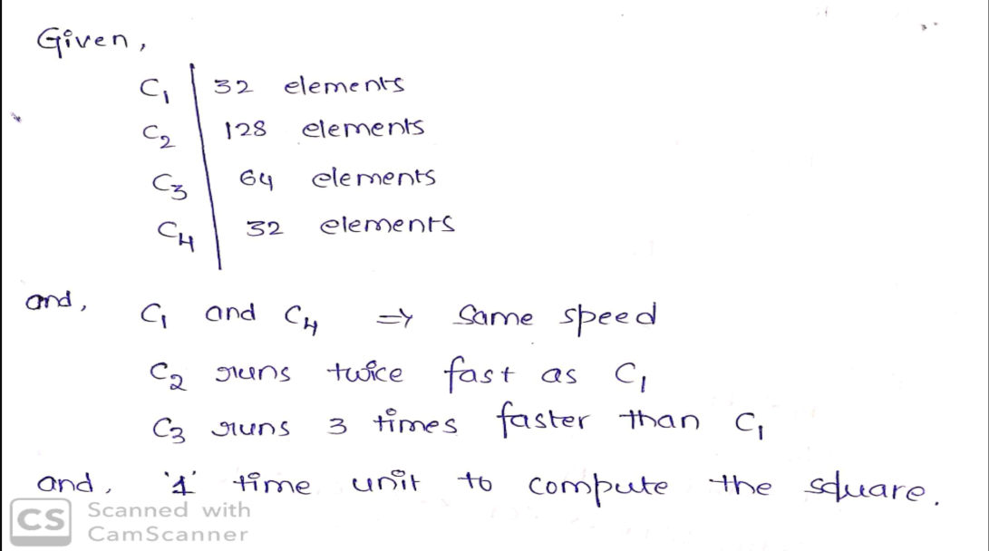

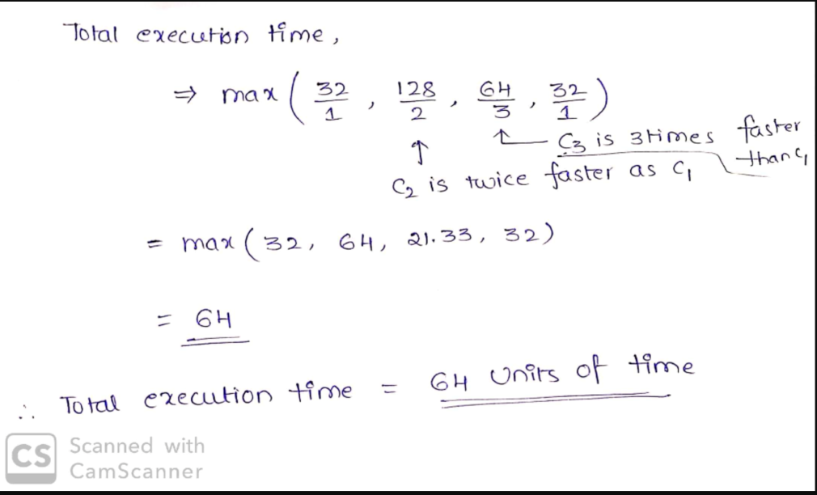

*********************************************************************************************************************

Question 3: (2013 – 2014, 2016 - 2017)

Consider a multicore processor with 6 heterogeneous cores sequentially labelled A-F. Assume cores A
and F have the same processing capabilities, B and C run twice as fast as A, and D and E 4 times
faster. Assume all cores are calculating a double precision vector-matrix multiplication using the
operations daxpy for an vector of length 512 and a square matrix 256x256. Assume 1 time unit per
daxpy on A or F. Given the following division of labour on the six cores:
A= 64 elements; B= 64 Elements; C= 64 Elements; D= 64 Elements; E=128 Elements; and, F= 128
Elements.
Compute a) Completion time and b) core utilisation rate and c) Propose an improved allocation of tasks to processors and calculate its utilisation rate

Question 4: (2014 – 2015)

For a given program, 99% of its code is parallelisable, i.e. 1% of the code is sequential/serial. If this
program is executed on the Sequoia - BlueGene/Q system with 1,572,864 (nearly 1.6 million) cores
and runs at the same speed on all cores without overheads:
a) What is the parallel speedup on
• 8;
• 160;
• 16,000;
• 1,600,000 cores.

- If the serial part is reduced to 0.1%, what is the parallel speedup on 1.6 million cores.

“YOU CAN SOLVE THIS QUES USING BELLOW METHOD”

Question 5: (2015 – 2016)

(i) For a given program, 98% of its code is parallelisable. If this program is executed on a multiprocessorsystem and runs at the same speed on all processors without additional overheads, whatis the parallel speedup on:
10;
100;
10,000;
1,000,000 cores.
(ii) If the serial part is reduced to 0.2%, what is the parallel speedup on 10,000 cores.
(iii) Discuss why the speedup exhibits the behaviour shown.

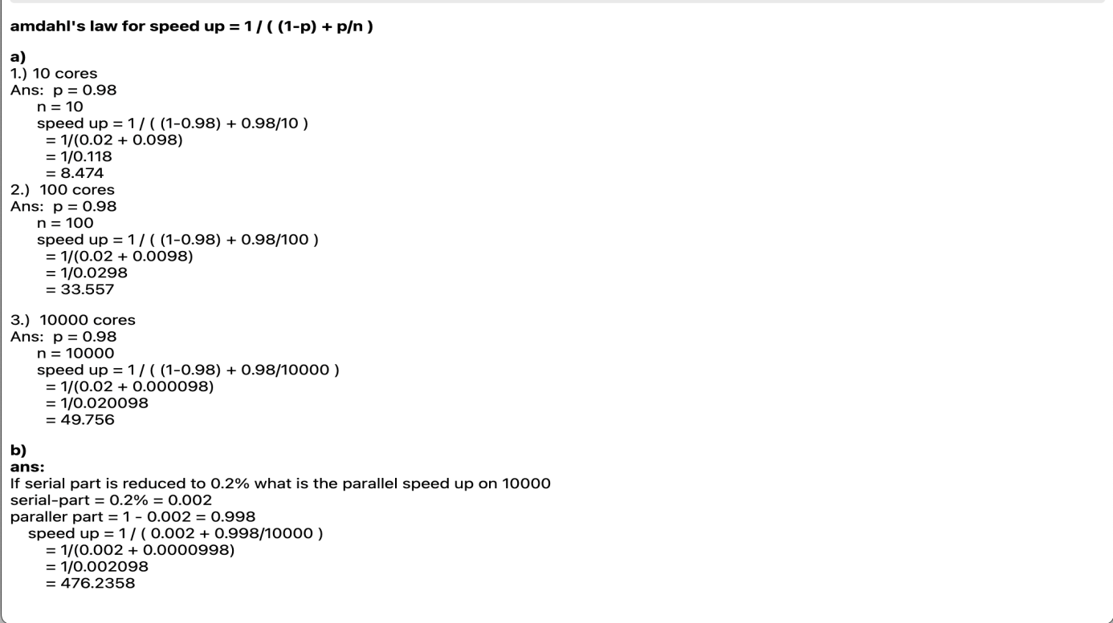

Question 6: (2015 – 2016)

Consider a multicore processor with 6 heterogeneous cores sequentially labelled A-F.
Assume cores A and E have the same processing capabilities, B,C and D run four times as fast as A
and F is two times faster than A. Assume all cores are calculating a double precision vector-matrix

multiplication using the operations daxpy for an vector of length 512 and a square matrix 256x256.
Assume 1 time unit per daxpy on A or F. Given the following division of data on the six cores:
A= 128 Elements; B= 64 Elements; C= 128 Elements; D= 64 Elements; E=64 Elements; and, F= 64
Elements.
Compute the Completion time.

(iii) Comment on the load distribution in (ii) and propose an improved allocation of tasks.

Question 7: (2016 – 2017, 2019 - 2020)

Assume a cluster with redundancy in a given datacentre. When a node fails, it takes 10 seconds to
diagnose the fault and another 30 seconds for the workload to switch over.

a) What is the availability of the cluster if planned downtime (maintenance) is ignored?.
b) What is the availability of the cluster including planned downtime?. Assume the cluster is off
one hour per week for maintenance.
c) The datacentre SLA states four nines. What is the maximum planned downtime per week to
fulfil with the SLA, assuming one failure per year?
d) Discuss an architectural approach to improving general system availability using an example

Question 8: (2016 – 2017)

A given program has 99.9% of its code parallelisable. If this program is executed on a parallel
machine, what is the parallel speedup on (9 marks)
• 8 cores
• 16,000 cores
• 1,600,000 cores

Question 9: (2016 – 2017)

Cloud Provider has a maximum time to repair (MTTR) a failed component in its cloud
infrastructure of 10 minutes. Assuming a maximum of one failure per year, calculate the annual
availability without planned downtime.

Question 10: (2014 – 2015)

For a given program, 99% of its code is parallelisable, i.e. 1% of the code is sequential/serial. If this
program is executed on the Tianhe-2/MilkyWay-2 system with 3,120,000 cores and runs at the same
speed on all cores without overheads:
a) What is the parallel speedup on:
• 10;
• 100;
• 10,000;
• 1,000,000 cores.
b)If the serial part is reduced to 0.1%, what is the parallel speedup on 1 million cores.

Question 11: (2014 – 2015)

A given Cloud Service Provider (CSP) assures that, in case of failure, the maximum time to repair
(MTTR) a failed component in its cloud infrastructure is 10 minutes. Assuming a maximum of one
failure per year:
a) Calculate the annual availability without planned downtime.
b) If this CSP wants to offer a five nines SLA based on the availability, what is an acceptable
MTTR assuming 1 failure per year with no planned downtime ?
c)Discuss the design approaches you would use to minimise the impact on failure in clouds.
I apologize for the mistake in my previous response. The annual availability without planned downtime for a given MTTR can be calculated using the following formula:
Availability = 1 - (MTTR / (365 days/year * 24 hours/day * 60 minutes/hour))
Using this formula, we can calculate the annual availability without planned downtime for the CSP with an MTTR of 10 minutes:
Availability = 1 - (10 minutes / (365 days/year * 24 hours/day * 60 minutes/hour)) = 0.9999
To achieve a five nines SLA, the annual availability must be at least 99.999%. The MTTR must be set so that the annual availability is at least this high.
To calculate the acceptable MTTR, we can rearrange the formula for annual availability to solve for MTTR:
MTTR = (365 days/year * 24 hours/day * 60 minutes/hour) * (1 - Availability)
Substituting in the desired annual availability and the maximum number of failures per year, we get:
MTTR = (365 days/year * 24 hours/day * 60 minutes/hour) * (1 - 0.99999)
MTTR = 525,600 minutes/year * 0.00001 = 5.256 minutes
So an acceptable MTTR for a five nines SLA based on the availability with 1 failure per year and no planned downtime would be approximately 5.256 minutes.

Question 12: (2017 – 2018)

For a given computer program, 99.8% of its code is parallelisable, i.e. 0.2% of the code is
sequential/serial. Assume that the program is to be executed on the #1 supercomputer in the Top500
Jun17 List, i.e. the Sunway TaihuLight - Sunway MPP with 10,649,600 cores. Assume that the
application will use from 100 up to 10 million cores as specified below. Note that all cores execute at
the same speed without overheads.
a) Based on the canonical Amdahl’s law, what is the parallel speedup on:
• 100;
• 10,000;
• 1,000,000; and
• 10,000,000 cores.
b) If the serial part is subsequently reduced to 0.02%, what is the parallel speedup on 10 million
cores? What is then the optimal number of cores to be used for this code? N.B. In this context,
optimal refers to the maximum number of cores which can be used to maintain scalability.
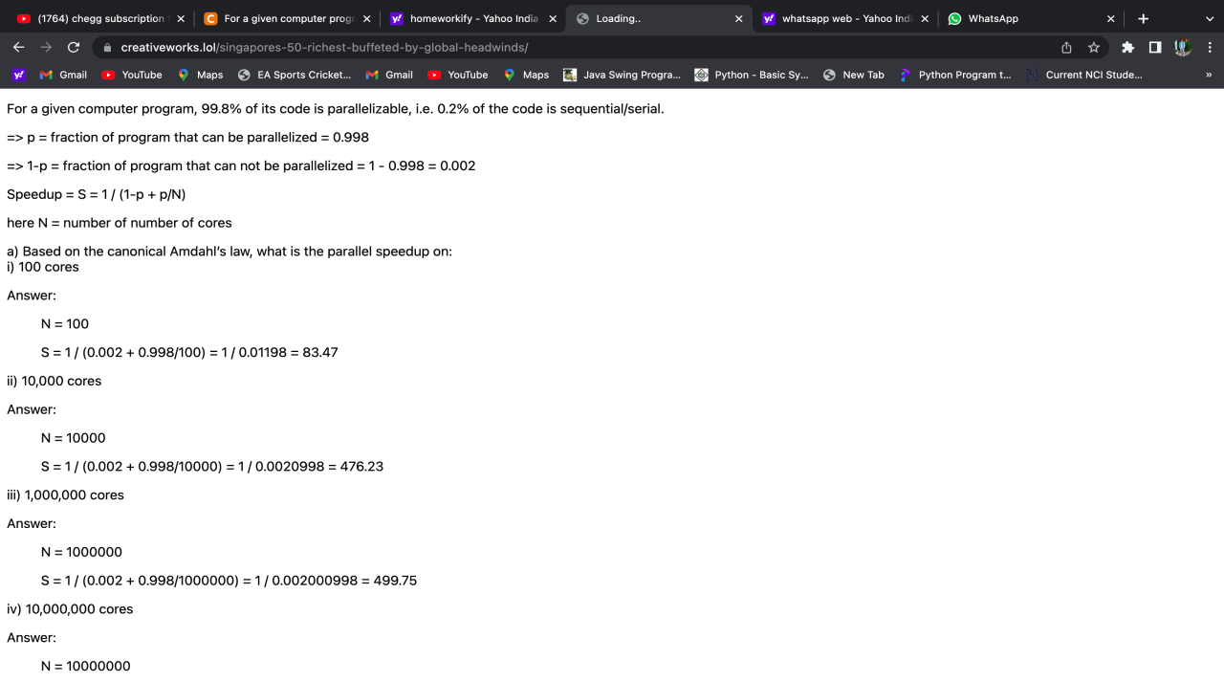
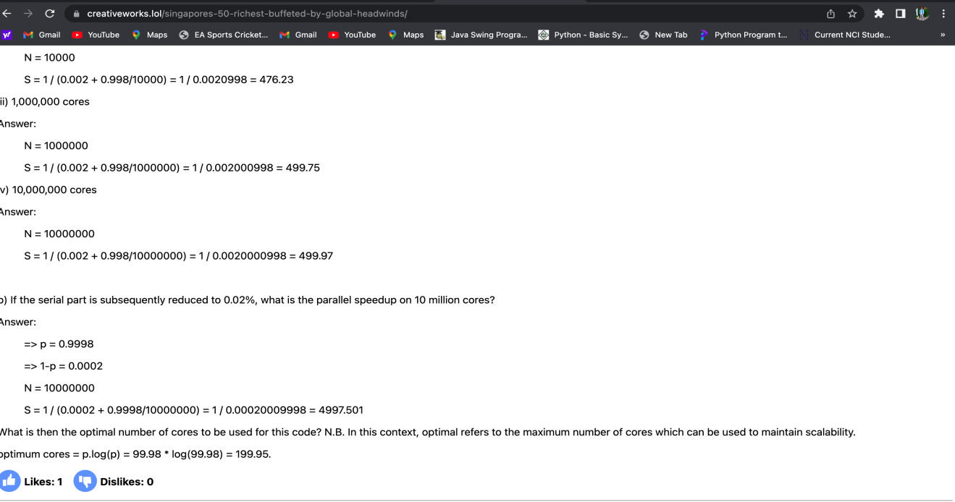

Question 13: (2017 – 2018)

Consider in figure below with a server-client cluster with an active-takeover configuration between
two identical servers. The servers share a disk via a SCSI bus. The clients (PCs or workstations) and
the Ethernet are fail-free. When a server fails, its workload is switched to the surviving server

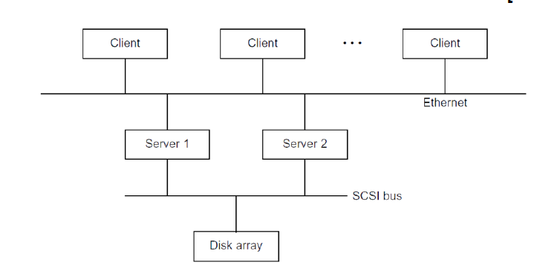
• Assume that each server has an MTTF of 200 days and an MTTR of five days. The disk has an
MTTF of 800 days and an MTTR of 20 days. In addition, each server is shut down for maintenance
for one day every week, during which time that server is considered unavailable. Only one server is
shut down for maintenance at a time. The failure rates cover both natural failures and scheduled
maintenance. The SCSI bus has a failure rate of 2 percent. The servers and the disk fail
independently. The disk and SCSI bus have no scheduled shutdown. The client machine will never
fail.
a. The servers are considered available if at least one server is available. What is the combined
availability of the two servers?
b. In normal operation, the cluster must have the SCSI bus, the disk, and at least one server
available simultaneously. What are the possible single points of failure in this cluster?

Question 14: (2018 – 2019, 2019 - 2020)

Consider the standard matrix multiplication method for two square matrices as shown below:

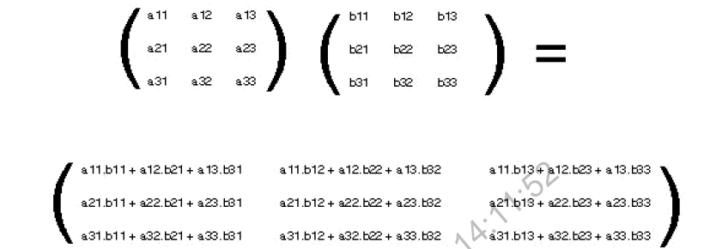

Given matrices of order M (MxM), the time complexity of the sequential multiplication time can be
defined as T1= cM3 units of time, where c is a hardware-dependant constant.
Assume that a MPI parallel code requires Tn=cM3/n + dM2/n units of time to complete on a
n-node configuration, where d is a constant determined by the MPI implementation used. The
second term in Tn accounts for the total message passing overhead experienced.

Answer the following questions assuming the MPI parallel code has no sequential bottleneck, is used
for a matrix of order 256 (M=256), and executed on a 4096-node cluster (n=4096) with a
hardware configuration with constant c=1. For parts a) and b) assume an implementation of MPI
(e.g MPICH-2) with d=4.

- Using the canonical Amdahl’s law, calculate the speedup of the parallel code on n nodes.

- What is the efficiency of the n-node cluster

c) Assume now a MPI implementation which incorporates the MPI-3 RMA interface and has a
d=0.
i. What is the new speedup and efficiency on n nodes?
ii. Please explain the RMA concept and its relation to the d parameter, ideally using the
following module reference papers:
• M Snir: Technical perspective: The future of MPI. CACM 61(10): 105 (2018)
• R Gerstenberger, M Besta, T Hoefler: Enabling highly scalable remote memory access
programming with MPI-3 one sided. CACM 61(10): 106-113 (2018).

Question 15: (2018 – 2019)

For the OpenStack private cloud shown below, consider the System Availability (A) of in terms of
MTTF (Mean Time to Failure), MTTR (Mean Time to Repair) and RMT (Regular Maintenance Time).

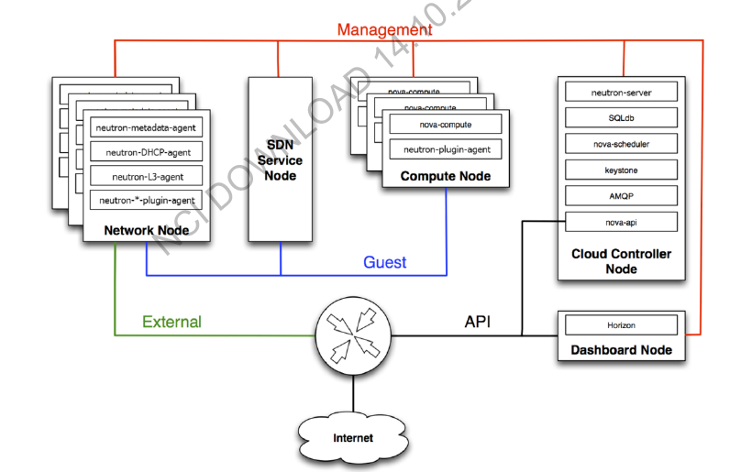
Assume this OpenStack private cloud has:
• An end-to-end two-nines SLA i.e. the system availability is considered from any Internet
client up to any service/node (A=99%);
• MTTF of one year; and
• MTTR of 48 hours.
What is the value of RMT (hours per month) the OpenStack cloud administrator should schedule
to comply with the SLA?
A:- 1.68hrs

Question 16: (2018 – 2019)

Dublin-based Cloudenci is considering a new public cloud offering that assures a maximum
time to repair (MTTR) of 600 seconds for any given failed component in its cloud
infrastructure. Assuming a maximum of one failure per year:

a) Calculate the annual availability without planned downtime

b) If Cloudenci wants to offer a five nines SLA based on the availability, what is an
acceptable MTTR assuming 1 failure per year with no planned downtime?

c) Discuss one of the following design approaches and its impact on failure in clouds:
Service degradation, Buffering, Automation

- Discuss Brewer's CAP Theorem2 and the design choices it provides to handle failures

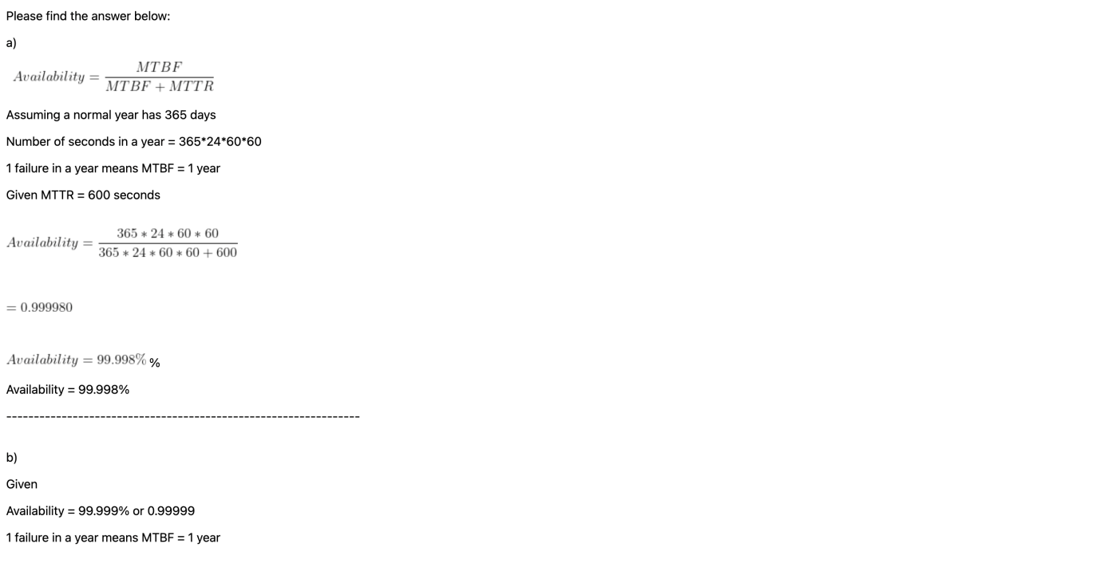

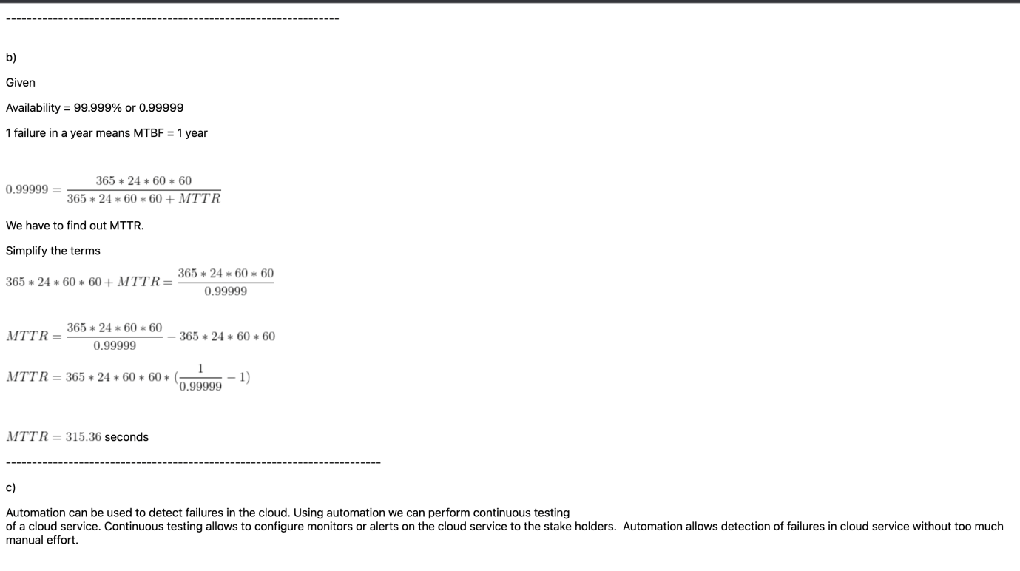

Question 17: (2018 – 2019)

Modern multicore processors have variable core speeds e.g. the 9th generation Intel i9-
9900K multicore processor has variable frequency in its 8 cores (3.60Ghz base, 5Ghz
maximum).
Consider a given parallel task—composed of DAXPY3 functions only—executing on a
variable-speed multicore processor, which employs 4 heterogeneous cores labelled C1,
C2, C3, and C4. Assume cores C1 and C4 operate at the same speed. C2 runs twice as fast
as C1 and core C3 runs 3 times faster than C1.
Assume all four cores start executing DAXPY at the same time and no cache misses are
encountered on any core operation. Suppose the parallel task uses two vectors x and y
with 1024 elements for all DAXPY operations. Assume 1 unit of time for C1 (or C4) to
compute DAXPY.
Given the following division of labour in four cores:
C1: 128 elements C2: 512 elements C3: 256 elements C4: 128 elements
a) Calculate the total execution time (in time units) for the four cores to compute the
parallel task on the 1024-element array

b) Propose an improved allocation elements-to-cores and calculate the new total
execution time and utilisation

- Using the Flynn’s taxonomy, define MIMD and SIMD

d) The development team is considering using GPU use. Critically compare GPU, GPGPU,
and multicore CPU and explain the advantages and disadvantages of each, giving
examples

Question 18: (2018 – 2019)

The standard Linpack benchmark employed for the Top500 list solves a dense mxmsystem of linear
equations. The time complexity for the sequential algorithm can be approximated by 2/3m3+2m2.
Assuming there is a MPI parallel Linpack code which requires:

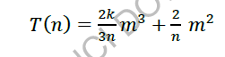
where k is a hardware-dependant constant.
Answer the following questions assuming the parallel code has no sequential bottleneck, and
executed on a 10,000-node cluster.

a) Using the canonical Amdahl’s law, calculate the value of k where the cluster can deliver an
efficiency of 99% speedup using the parallel code for Linpack 100 and Linpack 1000 (i.e.
matrices of order 100 and 1000 respectively).

b) Assume now a MPI implementation which incorporates the MPI-3 RMA interface and has a
k=1.

i. What is the new speedup and efficiency for Linpack 100 and 1000?
ii. Please explain the RMA concept and its relation to the k parameter, ideally using the
following module reference papers:
• M Snir: Technical perspective: The future of MPI. CACM 61(10): 105 (2018)
• R Gerstenberger, M Besta, T Hoefler: Enabling highly scalable remote memory access
programming with MPI-3 one sided. CACM 61(10): 106-113 (2018)

Question 19: (2019 – 2020)

AMD launched its 12-core Ryzen 9 3900X processor with dual clock 3.8 and 4.6 GHZ during the first
half of 2019. For the purpose of this exercise, consider only 6 of those cores—labelled “A” to “F”—
and assume they have variable processing capabilities. Assume these six cores are calculating a
double precision vector-matrix multiplication using the operations saxpy1 for vectors X and Y of
length 512. Assume cores A and F have the same processing capabilities, B and C run twice as fast
as A, and D and E 4 times faster. Assume 1 time unit per daxpyon A or F for a vector pair (x[i] and
y[i]). Given the following division of labour on the six cores:

• A= 128 vector pairs;
• B= 64 vector pairs;
• C= 64 vector pairs;
• D= 128 vector pairs;
• E=64 vector pairs; and,
• F= 64 vector pairs.

a) Compute completion time
b) Calculate core utilisation rate
c) Propose an improved allocation of tasks to processors and calculate its utilisation rate

20. Consider the System Availability (A) of a server cluster in terms of three parameters: namely the mean time to failure (MTTF), the mean time to repair (MTTR), and a regular maintenance time (RMT). The MTTF reflects the average uptime between two adjacent natural failures. The MTTR is the downtime due to natural failure. The RMT refers to scheduled down time for hardware/software maintenance or updates. Given a cloud system with a demanded availability A = 98%. If the MTTF is known to be two years (or 365× 24 × 2 = 17,520 hours) and the MTTR is known 24 hours, what is the value of RMT in hours per month that you can schedule for this cloud system?

SOLUTION:-
A) Please find the below answer
Availability = MTTF / MTTF + MTTR + RMT
17250 + 24 + RMT = 17250 / 0.98
RMT = 328 Hrs
This is maintanance time for period of 2years ( 24 months )
RMT per months is = 328 / 24
= 13.67 Hrs/month
*********************************************************************************************************************

